**DSA Assignment 2**

**https://github.com/PrathamAsrani/DSA_C/blob/master/assignment_stack.c**

#include<stdio.h>

#include <stdlib.h>

struct Array

{

    int *arr;

    int index, size;

};

/*Array Implimentation Function*/

void intialize(struct Array *a);

int create(struct Array *a);

int input(struct Array *a);

void display(struct Array a);

/*Array Implimentation Function*/

/*SunSet_View*/

int SunSet_View(struct Array a);

int main(){

    struct Array array;

    intialize(&array);

    create(&array);

    SunSet_View(array);

    return 0;

}

void intialize(struct Array *a)

{

    a->index = -1;

    printf("Enter the Number of Buildings : ");

    scanf("%d", &(a->size));

    printf("%d\n", a->size);

}

int create(struct Array *a)

{

    a->arr = (int *)malloc(a->size * sizeof(int));

    input(a);

}

int input(struct Array *a)

{

    int element;

    printf("Enter the Lenghts of Building from west to east : \n");

    for (int i = 0; i < a->size; ++i)

    {

        scanf("%d", &element);

        a->index++;

        *(a->arr + a->index) = element;

    }

}

void display(struct Array a)

{

    for (int i = 0; i < a.size; ++i)

    {

        printf("%d ", a.arr[i]);

    }

    printf("\n");

}

int SunSet_View(struct Array a){

    int count = 0;

    printf("The building having view to sunset are : ");

    for(int i = 0; i < a.size; i++){

        if(i == 0){

            count++;

            printf("%d ", i+1);

        }else if(i>0 && i < a.size-1){

            if(a.arr[i] < a.arr[i+1]){

                printf("%d ", i+2);

                count++;

            }

        }

    }

    printf("\nThe number of buiding watching Sunset : %d\n", count);

}

**Output:**

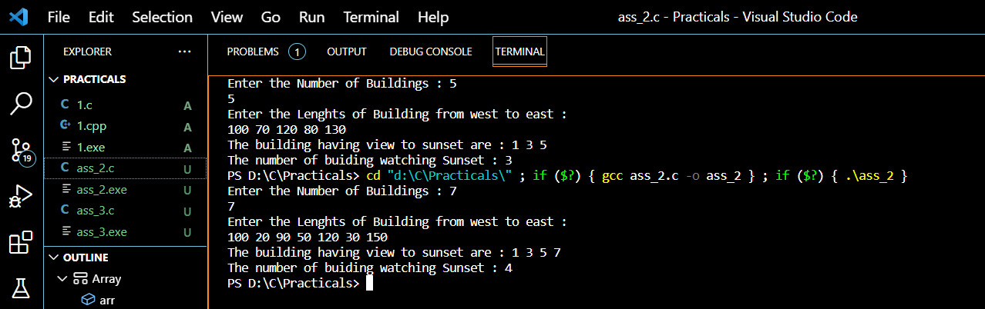

**Result : Hence we successfully used Array ADT to check whether the number of building having sunset view.**